*Imperial College of Engineering*

(RU Affiliated)

Lab Report

BSC Engineering 1st year 1st semester Examination ,2024

Course title: Computer Maintenance and Engineering Drawing

Course code: CSE1112

|  |  |
| --- | --- |
| **Submitted by:** | **Submitted to:** |
| **Name: MD Rashidul Islam Zidan** | **Aparna Haldar** |
| **Roll:23109** | **Lecturer, Department of Computer Science & Engineering** |
| **Session:2023-24** | **Imperial College of Engineering** |

Date: 05/10 /2024

# **INDEX**

|  |  |  |
| --- | --- | --- |
| **LAB NO** | **Content** | **Page** |
| 01 | Assemble different  parts of a computer | 3-6 |
| 02 | Install different types of application software and utilities software. |  |
| 03 | Install different types of Operating System such as Windows 10 |  |
| 04 | Partition a computer hard disk. |  |
| 05 | Fault findings Detect hardware related problems in CPU and fine the solution. |  |
| 06 | Getting familiar with DOS and its commands. |  |

**Lab: 1**

**Assembling different parts of a computer:**

* **Hard disk drive:**
* A hard disk drive (HDD) is a data storage device used for storing and retrieving digital information using rapidly rotating disks (platters) coated with magnetic material. Data is written and read from the disks using magnetic heads positioned on moving arms. HDDs are commonly found in computers, laptops, and servers for long-term data storage.
* **CPU (Central Processing Unit):**
* The CPU, or Central Processing Unit, is the primary component of a computer responsible for executing instructions and performing calculations. It acts as the brain of the computer, processing data and carrying out tasks required by software programs. The CPU interprets instructions fetched from memory, performs arithmetic and logic operations, and controls the flow of data within the system. It is typically a small, square-shaped chip located on the computer's motherboard.
* **Motherboard:**
* A motherboard is the main printed circuit board (PCB) in a computer. The motherboard is a computer's central communications backbone connectivity point, through which all components and external peripherals connect. Motherboards can be found in virtually all computers, especially desktop and laptop PCs.



**Hard disk drive**

**Fig:01**

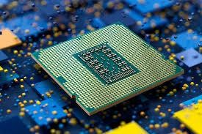

**Fig 02: CPU**

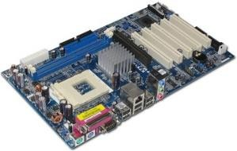

**Fig 03: Motherboard**

* **RAM (Random Access Memory) / ROM (Read-Only Memory):**
* RAM (Random Access Memory) and ROM (Read-Only Memory) are two essential types of memory in a computer, each serving different purposes. **RAM** is a volatile memory that temporarily stores data and instructions currently in use, allowing the CPU quick access to run programs and perform tasks efficiently. Since it’s temporary, all data in RAM is lost when the computer powers off. **ROM**, on the other hand, is non-volatile and permanently stores critical instructions needed for the computer to boot up, like the firmware (BIOS or UEFI).
* **CD/DVD (Optical Disc Drives):**
* The full form of DVD is Digital Versatile Disc. DVD is a digital optical disc storage format which was developed and invented in 1995 and used to store high- capacity files, such as top-standard videos and movies.

compact disc (CD), a molded plastic disc containing digital data that is scanned by a laser beam for the reproduction of recorded sound and other information.

* **Keyboard:**
* The keyboard is an input device that allows users to enter text, commands, and data into the computer. It consists of keys for letters, numbers, and functions, enabling interaction with software applications.
* **Mouse:**
* 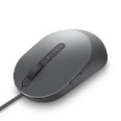The mouse is a pointing device that allows users to interact with the graphical user interface (GUI) by moving the cursor and clicking on elements. It enables easy navigation and control within software environments.

**Fig 07:Mouse**

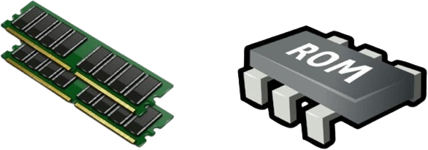

**RAM & ROM**

**Fig:04**

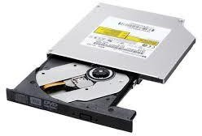

**Fig 05: DVD**

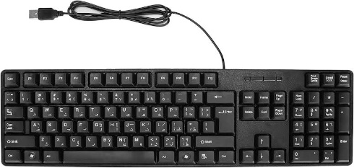

**Fig 06: Keyboard**



* **SATA Cable:**
* Serial Advanced Technology Attachment (SATA) or Serial ATA cables are used to connect devices in computer cable assemblies, such as storage devices, for example. The SATA technology itself is a connecter interface primarily used for computer bus connections in storage applications.
* **USB Port:**
* Definition: What a USB Port IsA USB port is a standard cable connection interface for smart phones, computers, and other consumer electronics devices. USB stands for Universal Serial Bus, an industry standard for short-distance digital data communications.
* **Input Device:**
* **Input refers to any information or data that is sent to a computer for processing. It is often sent to the computer from a device such as a keyboard, mouse, or another device. Putting it simply, it is the act of entering data into a computer**.
* **Output Device:**
* 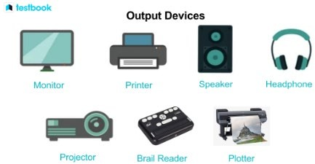**Output is used to refer to the amount of something that a person or thing produces. Manual workers need a good breakfast for high-energy output. Government statistics show the largest drop in industrial output for ten years. Synonyms: production, manufacture, manufacturing, yield More Synonyms of output.**

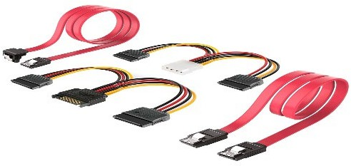

**Fig 08:** **SATA Cable**

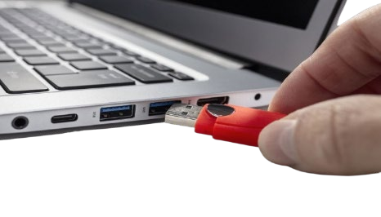

**Fig 09: USB Port**

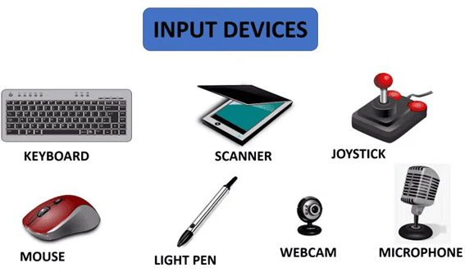

**Fig 10: Input device**

**Fig 11:Output device**

* **Heat Sink:**
* Heat sinks are widely used for cooling parts and components that produce heat while in use. The simple answer to the question, “What is a heat sink?”, is that it gradually transfers heat energy away from a heat source. So, in a sense, heat sinks are closely tied to electronics cooling
* **Power Supply:**
* **A power supply unit is used to provide stable electricity. The device converts and supplies electricity of the required voltage and frequency, excluding noise from the electricity obtained from an electrical outlet. Power supplies are classified by applications for available DC, AC, and output voltage ranges.**
* **Cooling Fan:**
* Cooling fans are also known as panel fans, they are an ideal solution for application that requires high efficiency and silent operation. The cooling fans work by sucking the cold air at the bottom vent, and thereby realizing hot air from the top vent as the heat rises upward

**Source:-** [**https://www.google.com/search?q=Assembling+different+parts+of+a+computer+with+image&sca_esv**](https://www.google.com/search?q=Assembling+different+parts+of+a+computer+with+image&sca_esv)

[**https://chatgpt.com/c/6705488e-3034-8005-9f27-cf5fd55d5fa8**](https://chatgpt.com/c/6705488e-3034-8005-9f27-cf5fd55d5fa8)

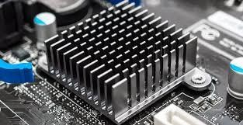

**Fig 11: Heat sink**

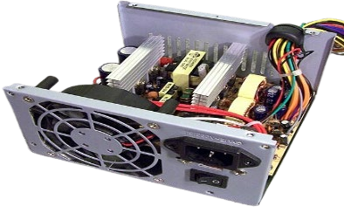

**Fig 12: Power supply**

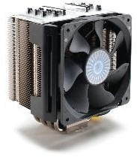

**Fig 13: Cooling fan**